

Computer Engineering Department.

Course Code and Name: Advanced Programing (CC319).

Course Instructor: Dr Diaa Fayed.

TA: Eng Mostafa Wahdan.

Project name: Hospital Management System.

Names: Ahmed Mohamed Hossam, Yasser Khaled, Ziad Ahmed Elsayed.

Table of Contents

|  |  |
| --- | --- |
| Content | Page Numbers |
| Cover page | 1 |

|  |  |
| --- | --- |
| Table Of Contents | 1 |
| Project Name | 2 |
| Project description | 2 |
| Programing Language | 2 |
| Other Recourses Needed | 3 |
| Project Requirements | 3 |
| Classes | 3 |
| Classes Relationships | 3 |
| Output | 4 |
| Conclusion | 5 |

Project Name

Hospital management System.

Project description

the admin has to log in first through a log in system by providing the username and password. Then, he can now register a patient by entering personal details such as Name, Gender, Address, Age, Status, Disease, Room Number and Price. The admin can also view the Patient’s Checkout by entering the Patient’s Id that contains the Patient Name, Gender, Date In-Out, Building, Room Number, Type, Status, Medicine Price and Total Bill. This **Hospital Management System** has features such as add room information and staff details. So, if they want to look for a room in the hospital the admin will simply enter the building number, room type, status and price. While in managing staff details, the admin can view it by entering the staff Name, Gender, Position, Contact Details and salary.

Programing Language

The language we use in this product is C Sharp because it is the most appropriate. Our project language that gives us the result we want

Other Recourses Needed

YouTube tutorial on how to make the hospitals management system

Project Requirements

1. Record reservations.

2. Record the customer’s first name, last name, phone number, number of occupants and room number. 3. Display the default room rate

4. Display whether or not the room is guaranteed

5. Record the expected check-in date and time

6. The system shall record the expected checkout date and time

7. The system shall check-in and check-out customers

8. The system shall allow reservations to be modified without having to reenter all the customer information

Classes

We have 6 classes

Patient Registration, Patient Information, Checkout, Room Info, Add Staff, View Checkout.

Classes Relationships

1. **Form Classes**: Represent different forms in the application, facilitating user interaction and navigation.
2. **DataSet Class (hospitalDataSet3)**: Manages the application's data, providing methods for data manipulation.
3. **Data Table Classes**: Define the structure of specific tables within the dataset, enabling interaction with database tables.
4. **Connection Strings**: Used by form classes to establish connections to the database for SQL operations.
5. **Event Handlers**: Contained within form classes, respond to user actions like button clicks, initiating operations.
6. **ADO.NET Classes**: Execute SQL commands and manage data, enabling communication with the database.

Output 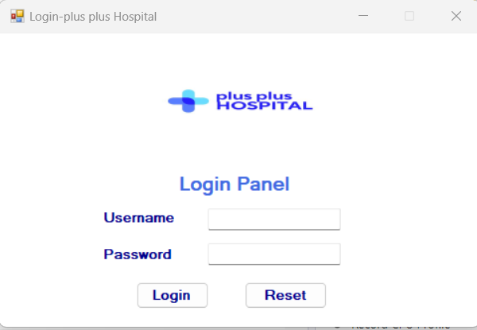

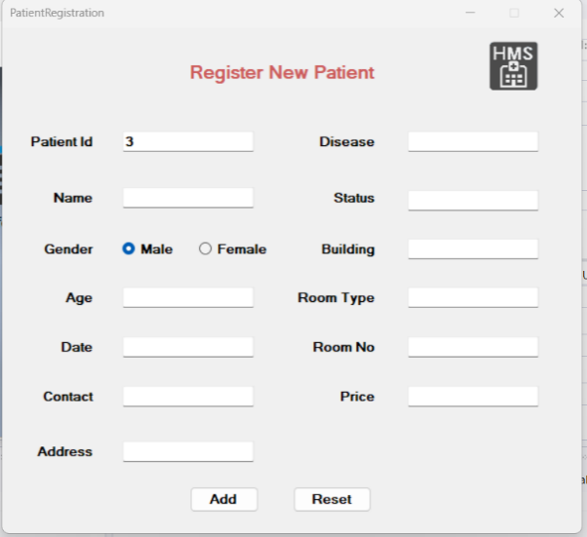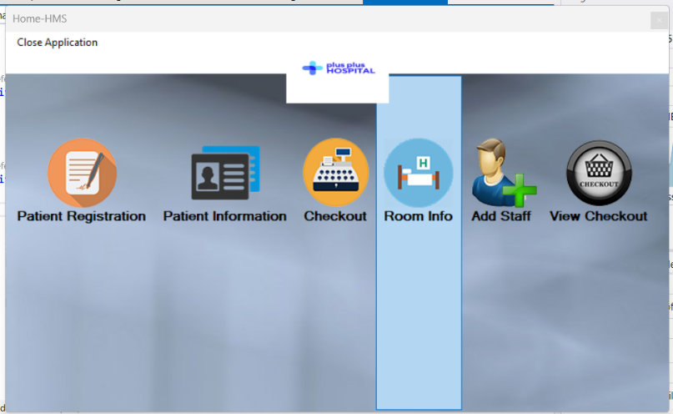

Conclusion

The Hospital Management System aims to revolutionize the way healthcare institutions manage their operations, leading to improved efficiency, accuracy, and patient care. By adhering to the outlined timeline and employing effective project management practices, we aim to deliver a robust and reliable solution that meets the needs of our stakeholders.